How to compute an Archaeological age by
Obsidian Hydration Dating

Alexander K. Rogers, MA, MS, RPA
Curator Emeritus, Maturango Museum
akr93555@gmail.com
Christopher M. Stevenson, PhD
Virginia Commonwealth University
Revised 2/9/2023
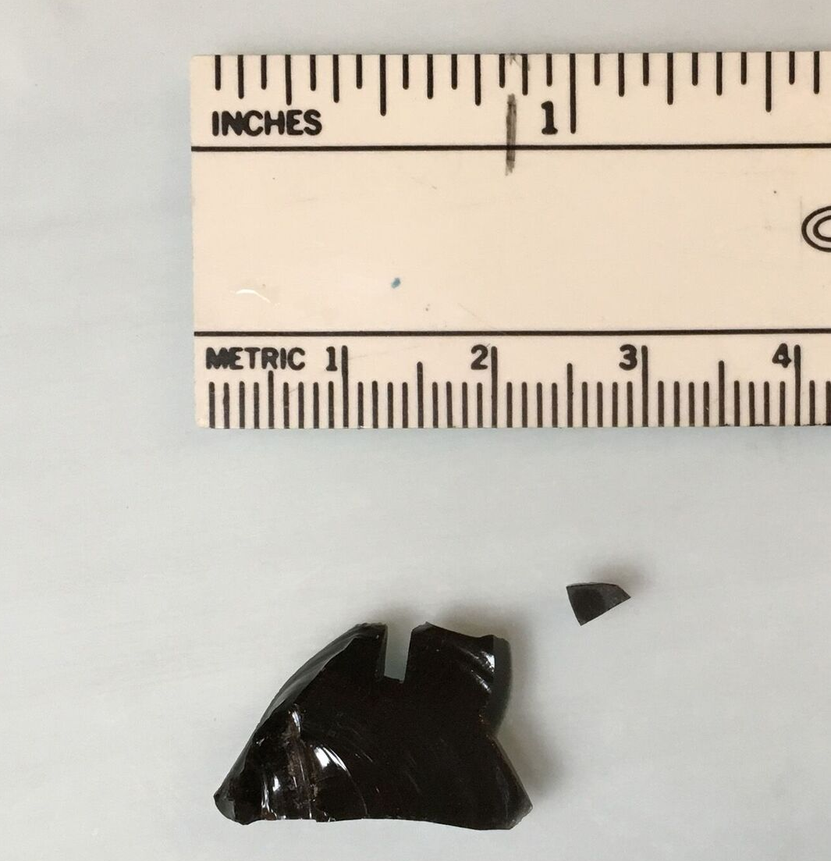
Working paper downloadable from
International Association for Obsidian Studies
https://www.deschutesmeridian.com/IAOS/

Summary
This pamphlet presents a step-by-step process for an archaeological age computation with obsidian hydration dating (OHD). It is intended for the practicing archaeologist, and a degree of knowledge of archaeological methods is assumed; however, no familiarity with OHD is assumed. Formulas necessary for OHD are summarized in the order they are used, as OHD is an inherently mathematical process, but mathematical derivations are omitted. References are provided to the details of methods for determining hydration rate and site temperature parameters, and to mathematical derivations for those interested.
Note: The process of making a hydration measurement causes damage to the specimen, and is regarded as “consumptive” by land managers and museums. Be sure you have appropriate approval before proceeding.

Overview of Obsidian Hydration Dating
(summarized from Rogers and Stevenson 2020, 2022)
- Obsidian hydration dating is based on the absorption of water by an obsidian specimen.
- Water diffuses into obsidian from any freshly-exposed surface, creating a hydrated layer, called a hydration rim or hydration rind. The depth of water penetration can be measured microscopically by the hydration rim thickness (see back cover), and is proportional to the square root of time since exposure of the surface. The “square-root-of-time” dependence is based on diffusion theory has been verified by laboratory measurements.
- Because of the square-root-of-time relationship, the age equation is
t = r²/k (1)
where t is age, r is the hydration rim thickness, and k is the diffusion (hydration) rate. No other age equation is valid.
- The hydration rate is determined primarily by two factors: the structural water content of the obsidian, and the temperature history of the specimen.
- Structural water content is primarily a function of the geochemical source, and is controlled by geochemical source determination (discussed further below).
- Temperature history is controlled by computation, based on the variation of hydration rate with temperature (the Arrhenius equation):
k = A*exp(-Q/T) (2)
where A is the pre-exponential constant, Q is the activation energy, and T is temperature. A is in μ²/unit time, and Q and T are in Kelvins (K = °C + 273.15). Controlling for temperature is discussed further below.
- The key parameter in controlling for temperature is the effective hydration temperature (EHT). Since archaeological temperatures vary seasonally and daily, eq. (2) shows that the hydration rate varies as well. The EHT is the single temperature which yields the same hydration rim as the actual varying temperature over the same time. Here the EHT for the hydration rate is designated EHT_{r}, and for a specimen as EHT_{s}.
- Computing a valid age requires controlling for source and temperature. Other less significant factors are included statistically in the computation of age accuracy (eqs. (9) and (10) below).

Data Set Preparation
- Make sure your catalog is complete and accurate. Doing so up front will prevent a great deal of pain and rework later.
- Select specimens for analysis, ensuring a reasonable sample size for each provenience unit. Make sure you have approval for cutting them. Remember that some will be unreadable by the lab, so pick a few extra. Include temporally-diagnostic artifacts as a check on your OHD computations. On bifaces or diagnostic artifacts, sample a few breaks as well as margins.
- Send samples to a geochemical lab for sourcing by XRF or NAA. Do not rely on visual sourcing.
- If you do not use geochemical sourcing, clearly document your assumptions about geochemical source.

- Send the same specimens for cutting and reading by an obsidian hydration (OH) lab.

Controlling for Structural Water Content
- Once you get the specimens and lab reports back, obtain a hydration rate for each geochemical source represented in your data set (methods are described in Rogers and Stevenson 2020:15ff.). The rate should be in μ²/1000 years, in terms of calendar years, not radiocarbon years (RCY) as use of RCY reduces accuracy.
- Determine the EHT for which the rate was computed, EHT_{r} (in °C); you will need this for the temperature correction process.
- Activation energy (Q), defined in eq. (2) above, is needed for hydration rim adjustment. Once you have each rate k and its corresponding EHT_{r}, the activation energy Q for that geochemical source is
Q = (EHT_{r} + 273.15)*[36.29 – ln(k)] (3)
where ln( ) is the natural logarithm and k is hydration rate in μ²/1000 years at EHT_{r} in °C.

Controlling for Temperature
- The hydration rim measured for each specimen (r_{m}) must be adjusted mathematically to the same EHT as the hydration rate.
- Computing specimen EHT_{s} requires three temperature parameters for the site (all are in °C):
Annual average temperature (T_{a});
Annual temperature variation (V_{a0}, hottest month mean minus coldest month mean);
Mean diurnal temperature variation (V_{d0}).
- These parameters can be computed from meteorological records or temperature sensors, and refer to conditions at the surface (methods are described in Rogers and Stevenson 2020:10ff.).
- For buried specimens, two of the parameters (V_{a0} and V_{d0}) must be adjusted for burial depth. The depth adjustment is
V_{a} = V_{a0}*exp(-0.44*z) (4a)
V_{d} = V_{d0}*exp(-8.50*z) (4b)
where z is artifact burial depth in meters.
- If the site is in a cave or rock-shelter, multiply V_{a} by 0.75 and set V_{d} = 5°C.
- Paleotemperature changes do not affect computed age significantly for ages < ≈13 Kyrs.
- EHT for each specimen is computed as
EHT_{s} = T_{a} + 0.0062*(V_{a}² + V_{d}²) (5)
- Once EHT_{s} is known, the rim correction factor is
RCF = exp[(Q/2)*(1/EHT_{s} – 1/EHT_{r})] (6)
where Q is the activation energy computed in eq (3).
- To check your results, note that:
if EHT_{s} > EHT_{r}, then RCF < 1;
if EHT_{s} = EHT_{r}, then RCF = 1;
if EHT_{s} < EHT_{r}, then RCF > 1.
- The EHT-adjusted hydration rim r_{c} is
r_{c} = r_{m} * RCF (7)
where r_{m} is the measured hydration rim.

Computing Age and Age Accuracy
- The age is computed as
t = 1000*r_{c}²/k (8)
where t is age in calendar years, r_{c} is the EHT- adjusted rim in microns, and k is hydration rate in μ²/1000 years at EHT_{r}.
- The coefficient of variation of the computed age is (Rogers and Yohe 2021)
CV_{t} = sqrt[(0.16/r_{m})² + 0.007*k₂₀ – 0.0581] (9)
where r_{m} is defined above and k₂₀ is the rate at EHT = 20°C. (See note on p. 11 for conversion).
- The standard deviation of the computed age is
σ_{t} = CV_{t} * t (10)
Both t and σ_{t} are in calendar years before the present.

When Major Changes in Burial Depth are Evident
- Sometimes a specimen is recovered at depth d₁, but it is obvious that a major change in depth has occurred, such as a heavy alluvial overburden or artifacts eroding out of a surface. For this case the artifact may have been recovered at depth d₁, but was at a depth d₂ for part of its life. Suppose further that it is possible to estimate that the artifact was at depth d₁ for Y fraction of its life. Then the best estimate of age is
t = r_{m}²/{k*[Y/RCF_{d1}² + (1 – Y)/RCF_{d2}²] (11)
where RCF_{d1} is the rim correction factor corresponding to depth d₁ and RCF_{d2} is the factor for depth d₂. In the absence of geoarchaeological data, Y = 0.5 is a best estimate.
- The standard deviation of age is then
σ_{t} = t*sqrt[(0.16/r_{m})² + 0.007*k – 0.0581
+ (t_{d1} – t_{d2})²/12] (12)
where t_{d1} is the age computed for depth d₁ and t_{d2} is the age computed for depth d₂.

Computation Method
- MS Excel is a convenient way to do the computations. The Excel workbook, downloadable from the IAOS website, has formulas built in, and can easily accommodate data sheets provided by OH labs.

Data Analysis Suggestions
- Diagnostic artifacts should be analyzed individually. Ages should be computed for each artifact, and then aggregates of ages should be considered if appropriate.
- Non-diagnostic artifacts such as debitage can be grouped before or after ages are computed, although it is preferable to treat them like diagnostic artifacts: compute the ages individually and then aggregate.
- Plotting OHD age vs. burial depth will give insights on whether the stratigraphy is intact or disturbed.
- When aggregating data, the mean age is simply the average of the individual ages. However, the standard deviation of the aggregate age is not simply the standard deviation of the mean ages: the standard deviation of the aggregate must also include the uncertainties due to the individual standard deviations from eq. (10) or (12).

The formula for the standard deviation of the aggregate of N ages is
σ = sqrt(σ_{m}² + ∑(σ_{a}²)/N) (13)
where σ_{m} is the standard deviation of the ages computed by eq. (8) and σ_{a} is the standard deviation computed for each age by eq. (10) or (12). Although it looks complex, eq. (13) can be easily implemented in MS Excel using the STDEVP and AVERAGE functions, since
σ_{m} = STDEVP(ages), and
∑(σ_{a}²)/N = AVERAGE(age standard deviations squared)
Data Presentation Suggestions
- Always present original data in tabular form, not just summaries or graphs.
- Include the geochemical and OH lab reports in your report.
- Clearly label tables and graphs; the reader should not have to flip pages to understand them.
- A caption for a graph should clearly state the data table which is the source.
- Explain outliers in the age computations; they are often traceable to the comments by the OH lab, such as “diffuse hydration”.
- Explain the basis on which you excluded any data points (judgmental, Chauvenet’s criterion, correcting procedural errors, …).
- Correlate ages of diagnostic artifacts with the ages expected for them.

References Cited
Note: These references are available at no cost from the website of the International Association for Obsidian Studies.

Rogers, Alexander K., and Christopher M. Stevenson
2020 Archaeological Age Computation Based on Obsidian Hydration: A Summary of the Current State of the Art. Bulletin of the International Association for Obsidian Studies Special Issue No. 63, March 2020, pp. 2-44.
2022 A Summary of Obsidian Hydration Dating Science and Method for Archaeologists. Working paper dated 9/10/2022, available for download on the IAOS website
Rogers, Alexander K. and Robert M. Yohe II
2021 An Equation to Compute Accuracy of Obsidian Hydration Dating Ages. Bulletin of the International Association for Obsidian Studies No. 67, Winter 2021, pp. 5-14.

Note regarding equation (9)
The value of k₂₀ in equation (9) is rate at a reference EHT of 20°C. If your rate k_{x} is for another EHT, say EHT_{x}, convert it to 20°C by the following equation before computing accuracy:

k₂₀ = k_{x}*exp[Q*(1/293.15 - 1/EHT_{x})]

User Notes

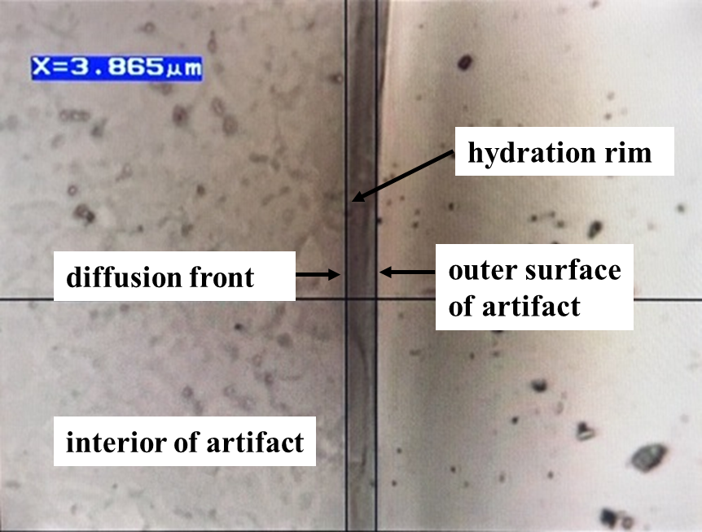

Cover photographs courtesy of J. Thatcher,
Willamette Analytics LLC

