**How to compute an Archaeological age by**

**Obsidian Hydration Dating**

Alexander K. Rogers, MA, MS, RPA

Curator Emeritus, Maturango Museum

akr93555@gmail.com

Christopher M. Stevenson, PhD

Virginia Commonwealth University

12/1/2022

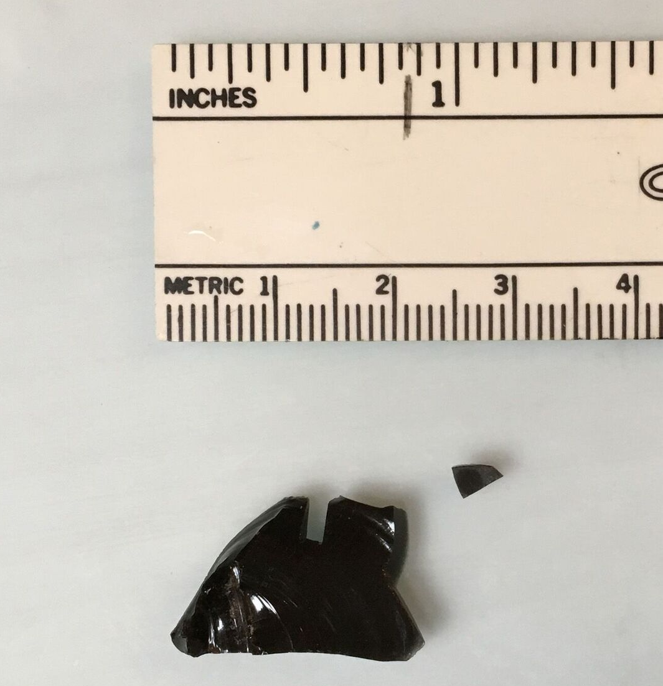

Working paper downloadable from

International Association for Obsidian Studies

https://www.deschutesmeridian.com/IAOS/

**Summary**

This pamphlet presents a step-by-step process for an archaeological age computation with obsidian hydration dating (OHD). It is intended for the practicing archaeologist, and a degree of knowledge of archaeological methods is assumed; however, no familiarity with OHD is assumed. Formulas necessary for OHD are summarized in the order they are used, as OHD is an inherently mathematical process, but mathematical derivations are omitted. References are provided to the details of methods for determining hydration rate and site temperature parameters, and to mathematical derivations for those interested.

Note: The process of making a hydration measurement causes damage to the specimen, and is regarded as “consumptive” by land managers and museums. Be sure you have appropriate approval before proceeding.

**Overview of Obsidian Hydration Dating**

(summarized from Rogers and Stevenson 2020, 2022)

* Obsidian hydration dating is based on the absorption of water by an obsidian specimen.
* Water diffuses into obsidian from any freshly-exposed surface, creating a hydrated layer, called a hydration rim or hydration rind. The depth of water penetration can be measured microscopically by the hydration rim thickness (see back cover), and is proportional to the square root of time since exposure of the surface. The “square-root-of-time” dependence is based on diffusion theory has been verified by laboratory measurements.
* Because of the square-root-of-time relationship, the age equation is

t = r2/k (1)

where t is age, r is the hydration rim thickness, and k is the diffusion (hydration) rate. No other age equation is valid.

* The hydration rate is determined primarily by two factors: the structural water content of the obsidian, and the temperature history of the specimen.
* Structural water content is primarily a function of the geochemical source, and is controlled by geochemical source determination (discussed further below).
* Temperature history is controlled by computation, based on the variation of hydration rate with temperature (the Arrhenius equation):

k = A*exp(-Q/T) (2)

where A is the pre-exponential constant, Q is the activation energy, and T is temperature. A is in μ2/unit time, and Q and T are in Kelvins (K = °C + 273.15). Controlling for temperature is discussed further below.

* The key parameter in controlling for temperature is the effective hydration temperature (EHT). Since archaeological temperatures vary seasonally and daily, eq. (2) shows that the hydration rate varies as well. The EHT is the single temperature which yields the same hydration rim as the actual varying temperature over the same time. Here the EHT for the hydration rate is designated EHTr, and for a specimen as EHTs.
* Computing a valid age requires controlling for source and temperature. Other less significant factors are included statistically in the computation of age accuracy (eqs. (9) and (10) below).

**Data Set Preparation**

* Make sure your catalog is complete and accurate. Doing so up front will prevent a great deal of pain and rework later.
* Select specimens for analysis, ensuring a reasonable sample size for each provenience unit. Make sure you have approval for cutting them. Remember that some will be unreadable by the lab, so pick a few extra. Include temporally-diagnostic artifacts as a check on your OHD computations. On bifaces or diagnostic artifacts, sample a few breaks as well as margins.
* Send samples to a geochemical lab for sourcing by XRF or NAA. Do not rely on visual sourcing.
* If you do not use geochemical sourcing, clearly document your assumptions about geochemical source.
* Send the same specimens for cutting and reading by an obsidian hydration (OH) lab.

**Controlling for Structural Water Content**

* Once you get the specimens and lab reports back, obtain a hydration rate for each geochemical source represented in your data set (methods are described in Rogers and Stevenson 2020:15ff.). The rate should be in μ2/1000 years, in terms of calendar years, not radiocarbon years (RCY) as use of RCY reduces accuracy.
* Determine the EHT for which the rate was computed, EHTr (in °C); you will need this for the temperature correction process.
* Activation energy (Q), defined in eq. (2) above, is needed for hydration rim adjustment. Once you have each rate k and its corresponding EHTr, the activation energy Q for that geochemical source is

Q = (EHTr + 273.15)*[36.29 – ln(k)] (3)

where ln( ) is the natural logarithm and k is hydration rate in μ2/1000 years at EHTr in °C.

**Controlling for Temperature**

* The hydration rim measured for each specimen (rm) must be adjusted mathematically to the same EHT as the hydration rate.
* Computing specimen EHTs requires three temperature parameters for the site (all are in °C):

Annual average temperature (Ta);

Annual temperature variation (Va0, hottest month mean minus coldest month mean);

Mean diurnal temperature variation (Vd0).

* These parameters can be computed from meteorological records or temperature sensors, and refer to conditions at the surface (methods are described in Rogers and Stevenson 2020:10ff.).
* For buried specimens, two of the parameters (Va0 and Vd0) must be adjusted for burial depth. The depth adjustment is

Va = Va0*exp(-0.44*z) (4a)

Vd = Vd0*exp(-8.50*z) (4b)

where z is artifact burial depth in meters.

* If the site is in a cave or rock-shelter, multiply Va by 0.75 and set Vd = 5°C.
* Paleotemperature changes do not affect computed age significantly for ages < ≈13 Kyrs.
* EHT for each specimen is computed as

EHTs = Ta + 0.0062*(Va2 + Vd2) (5)

* Once EHTs is known, the rim correction factor is

RCF = exp[(Q/2)*(1/EHTs – 1/EHTr)] (6)

where Q is the activation energy computed in eq (3).

* To check your results, note that:

if EHTs > EHTr, then RCF < 1;

if EHTs = EHTr, then RCF = 1;

if EHTs < EHTr, then RCF > 1.

* The EHT-adjusted hydration rim rc is

rc = rm * RCF (7)

where rm is the measured hydration rim.

**Computing Age and Age Accuracy**

* The age is computed as

t = 1000*rc2/k (8)

where t is age in calendar years, rc is the EHT- adjusted rim in microns, and k is hydration rate in μ2/1000 years at EHTr.

* The coefficient of variation of the computed age is (Rogers and Yohe 2021)

CVt = sqrt[(0.16/rm)2 + 0.007*k20 – 0.0581] (9)

where rm is defined above and k20 is the rate at EHT = 20°C. (See note on p. 11 for conversion).

* The standard deviation of the computed age is

σt = CVt * t (10)

Both t and σt are in calendar years before the present.

**When Major Changes in Burial Depth are Evident**

* Sometimes a specimen is recovered at depth d1, but it is obvious that a major change in depth has occurred, such as a heavy alluvial overburden or artifacts eroding out of a surface. For this case the artifact may have been recovered at depth d1, but was at a depth d2 for part of its life. Suppose further that it is possible to estimate that the artifact was at depth d1 for Y fraction of its life. Then the best estimate of age is

t = rm2*[Y/RCFd12 + (1 – Y)/RCFd22]/k (11)

where RCFd1 is the rim correction factor corresponding to depth d1 and RCFd2 is the factor for depth d2. In the absence of geoarchaeological data, Y = 0.5 is a best estimate.

* The standard deviation of age is then

σt = t*sqrt[(0.16/rm)2 + 0.007*k – 0.0581

+ (td1 – td2)2/12] (12)

where td1 is the age computed for depth d1 and td2 is the age computed for depth d2.

**Computation Method**

* MS Excel is a convenient way to do the computations. The Excel workbook, downloadable from the IAOS website, has formulas built in, and can easily accommodate data sheets provided by OH labs.

**Data Analysis Suggestions**

* Diagnostic artifacts should be analyzed individually. Ages should be computed for each artifact, and then aggregates of ages should be considered if appropriate.
* Non-diagnostic artifacts such as debitage can be grouped before or after ages are computed, although it is preferable to treat them like diagnostic artifacts: compute the ages individually and then aggregate.
* Plotting OHD age vs. burial depth will give insights on whether the stratigraphy is intact or disturbed.
* When aggregating data, the mean age is simply the average of the individual ages. However, the standard deviation of the aggregate age is *not* simply the standard deviation of the mean ages: the standard deviation of the aggregate must also include the uncertainties due to the individual standard deviations from eq. (10) or (12).

The formula for the standard deviation of the aggregate of N ages is

σ = sqrt(σm2 + ∑(σa2)/N) (13)

where σm is the standard deviation of the ages computed by eq. (8) and σa is the standard deviation computed for each age by eq. (10) or (12). Although it looks complex, eq. (13) can be easily implemented in MS Excel using the STDEVP and AVERAGE functions, since

σm = STDEVP(ages), and

∑(σa2)/N = AVERAGE(age standard deviations squared)

**Data Presentation Suggestions**

* Always present original data in tabular form, not just summaries or graphs.
* Include the geochemical and OH lab reports in your report.
* Clearly label tables and graphs; the reader should not have to flip pages to understand them.
* A caption for a graph should clearly state the data table which is the source.
* Explain outliers in the age computations; they are often traceable to the comments by the OH lab, such as “diffuse hydration”.
* Explain the basis on which you excluded any data points (judgmental, Chauvenet’s criterion, correcting procedural errors, …).
* Correlate ages of diagnostic artifacts with the ages expected for them.

**References Cited**

Note: These references are available at no cost from the website of the International Association for Obsidian Studies.

Rogers, Alexander K., and Christopher M. Stevenson

2020 Archaeological Age Computation Based on Obsidian Hydration: A Summary of the Current State of the Art. *Bulletin of the International Association for Obsidian Studies* Special Issue No. 63, March 2020, pp. 2-44.

2022 *A Summary of Obsidian Hydration Dating Science and Method for Archaeologists.* Working paper dated 9/10/2022, available for download on the IAOS website

Rogers, Alexander K. and Robert M. Yohe II

2021 An Equation to Compute Accuracy of Obsidian Hydration Dating Ages. *Bulletin of the International Association for Obsidian Studies* No. 67, Winter 2021, pp. 5-14.

**Note regarding equation (9)**

The value of k20 in equation (9) is rate at a reference EHT of 20°C. If your rate kx is for another EHT, say EHTx, convert it to 20°C by the following equation before computing accuracy:

k20 = kx*exp[Q*(1/293.15 - 1/EHTx)]

**User Notes**

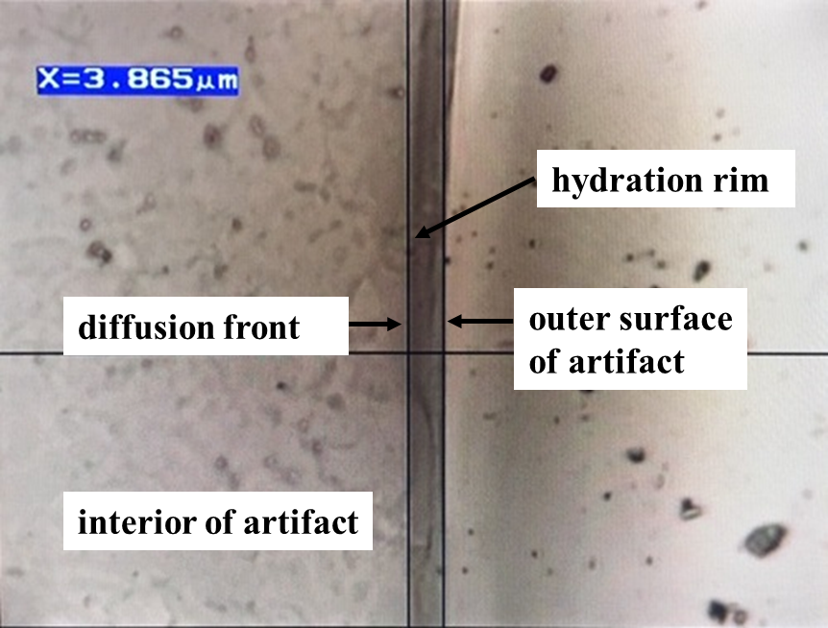

Cover photographs courtesy of J. Thatcher,

Willamette Analytics LLC